Using Esterel Approach to Design Complex Systems

Gilles Pélissier ¹, Lionel Blanc²

¹ STMicroelectronics CMSA team, 5bis chemin de la Dhuy – 38240 Meylan

{Gilles.Pelissier@st.com}

² Esterel Technologies, Twins 2, 885 av. du Dr J. Lefebvre - 06270 Villeneuve-Loubet

{Lionel.Blanc@esterel-technologies.com}

Abstract

In this paper, we focus on the relevance of the Esterel technology for the design of complex hardware systems. We put the emphasis on the absolute necessity to use dedicated and formal models to describe control flow, source of serious defects. We experiment the Esterel approach on a hardware component in a top-down co-design flow and outline the benefits of the Esterel chain, in terms of modeling, formal property verification and test coverage.

Introduction

Nowadays, Smart Electronic Devices locally integrate numerous services: to realize their initial function, to communicate, to inter-operate, to be maintainable, to reuse them, … Therefore, these equipments have to handle numerous events, tending to grow exponentially, increasing substantially the combinatorial complexity to be considered by a designer. Moreover, these systems require performance - they have to react in a dynamic compatible with the environment – and safety. Such systems are called reactive systems since they maintain a permanent interaction with their environment. Any of theses systems is essentially reactive. Such an application can be split in two parts : the reactive one and the algorithmic one. That constitutes a classical structure in the hardware design decomposed in a control and a data paths. The control part usually describes temporal scenarios and depends on the history. It constitutes the decisional organ of the application, i.e. the “brain”. The algorithmic part realizes data processing and provides results at its own speed. The criticality and the complexity of an application is essentially concentrated inside the control structure which decides when and what processing must be done. Experiments have shown that the control part represents on the average 30% of the application code. On the other hand, 70% of defaults are due to this control part. Therefore, the validation of the control flow constitutes a crucial point, since we cannot accept default for this kind of application. The combinatorial complexity of such systems makes it difficult to apply a classical validation policy with sufficient confidence. Finally, design of systems is more and more frequently integrated in a co-design flow.

It seems to be essential for the design of (hardware/software) applications to use models, methodology and tools well adapted to the critical control part modeling. The Esterel synchronous approach constitutes a relevant and efficient methodology to deal with the design and the validation (verification, testing) of the complex systems. Esterel Studio [1] is the commercial tool based on Esterel technology.

In section 2, we present the Esterel approach included in a top down co-design flow. Then we describe, in section 3, an experiment using this approach at ST Microelectronics. In section 4, we introduce the verification and testing phase in order to reach “zero-default” objective. Finally, we invoke perspectives and conclusions ensuing of this work.

Esterel Methodology in the top-down co-design flow

The Esterel/SyncCharts paradigms

The imperative Esterel language [2] provides judicious construction for the control flow description of applications. Handling events and describing the real-time structure is a must for Esterel. You can naturally and easily express interruptions (abortion), priorities, concurrency (natural parallelism), temporal scenarios … The main activity, for a designer, should be the behavior description of its applications by using a well-adapted model, i.e. for which the structures are the closest to what it has to express. In this sense, Esterel allows the designer to only concentrate his effort on the modeling phase. The difficult and heavy translation task falls within the competence of the compiler.

SyncCharts [4] is a graphical notation whose foundations are based on the Esterel language, i.e. SyncCharts and Esterel have equivalent structures. However, they do not have the same expression capability. SyncCharts is dedicated to the natural modeling of concurrent and hierarchical state machines. Esterel does not allow that so intuitively. SyncCharts and Esterel can be viewed like complementary formalisms. Esterel Studio tool [1] allows to unify these two models in a same view.

Another key point is the formal definition of these models: their semantics is mathematically well-defined. These approaches guarantee the non-ambiguity of expression and logical determinism. What you execute is always what you specify ! Esterel and SyncCharts are founded on synchronous semantic and instantaneous broadcasting of signals: produced information is immediately (at the same instant) visible by all its consumers. This synchronous hypothesis notably reduces the combinatorial complexity of an application (you do not have to consider the communication delay and the interleaving among communications). Moreover, whenever your way of thinking is “synchronous”, you do not have to think scheduling, i.e. the model, alone, characterizes the behavior (no need to express scheduling policy). That makes it easier to establish collaborative work within a design team.

Note that the modeling comfort of the Esterel approach is not paid on the generated code effectiveness. The Esterel compiler is based on hardware circuit description representing Boolean Equation Systems. That permits a linearity between Esterel source size and generated code size. From this optimized circuit description, the Esterel compiler can derive a hardware or a software code (Figure 1).

Figure 1: Esterel compilation flow

Therefore, the Esterel approach can naturally be integrated in a co-design flow.

The Esterel Methodology in the co-design flow

The design process starts with the designer creating a formal high-level specification in a SyncCharts graphical finite state machines notation. The aim is to apply formal verification methods in order to track and eliminate defects, or to produce useful test scenarios. Once the system functionality is validated by graphic simulations and by formal verifications, the specification is mapped into a software specification or into a hardware specification with its test patterns.

Today, a system designer would write system-level models in a high-level programming language such as C or C++. A system-level model in C/C++ can be quickly simulated to validate and optimize the design, explore various algorithms and provide the hardware and software development team with an executable specification of the system. CoWare N2C[6] is a practical solution, used in the real life design around the world that preserves the C software development paradigm for software people, adds the necessary clocking to C to enable hardware designers to move C functionality into a hardware architecture, and co-exists with existing hardware in Verilog or VHDL. The design flow in CoWare N2C allows you to define a block at different abstraction levels of C/C++: untimed level (UT), Bus-Cycle-Accurate level (BCA), and Register-Transfer C level (RTC), which can be automatically translated into RTL-VHDL (or Verilog) [8].

We can see on Figure 2 the different steps from formal executable specifications to the production of hardware specification.

Figure 2: Esterel to HW specification

The different steps are the following:
1 - Esterel generation from the graphic FSM,
2 - Graphical animation of the specification and debugging,
3 - Test environment for improving state coverage,
4 - Playing a scenario produced in 3,
5 - Reading scenarios from CoWare,
6 - Cosimulation between Esterel and CoWare,
7 - BCA generation to speed up the simulation,
8 - RTC & VHDL generation for the synthesis.

This methodology has been included in the STMicroelectronics top-down co-design flow [5] to produce several target codes at different abstraction levels: Bus Cycle Accurate (BCA), Register Transfer C (RTC), and RTL-VHDL. At the BCA level, the processes in the system are synchronized using a clock signal, variables can be used to avoid combinatorial process. The BCA level is used to rapidly validate blocks in the system environment which is described in CoWare [6] or System C [3]. At the RTC level, only signals can be seen by all processes, pointers are not supported, design conventions must be applied to allow for automatic translation of RTC into RTL-VHDL code. So, RTC code is at the same abstraction level than RTL-VHDL code, nevertheless RTC code allows to avoid costly co-simulation between VHDL and other blocks described in CoWare C. It must be understood that refining BCA level into VHDL induces larger simulation costs.

An experiment in using Esterel Studio for modeling a bridge

STBus to AVBus Bridge

We now propose an illustration of the Esterel modeling methodology in the top-down co-design flow of STMicroelectronics. We present a module called AVB1 which is a bridge between a STBus and an AVBus. The AVB1 is used as an interface between the two subsystems. The first subsystem around the AVBus is an Audio/Video decoder with a graphic processor, a display processor and memories. The second subsystem around STBus consists of a RISC processor, and several external interfaces.

Figure 3: STBus to AVBus Bridge

The aim of AVB1 is to connect two buses which have not the same width, the same clock and the same asynchronous protocol. The bridge has been chosen because it is essentially composed of FIFOs and control parts. Only control dominated parts can be programmed using Esterel Studio while data dominated parts are described in C/C++.
As shown on Figure 3 above, 4 control parts can be deduced from the specification. Control 1 called RQB (STBus Request Signals Buffer) allows to sample and to buffer when the request and grant signals are both asserted. The number of bytes to put into RQD (Request Data FIFO) is determined from the STBus opcode in case of store. If the RQD acknowledges write command, transaction type is put into RQT (Request Transaction Fifo) else grant signal is set low. Side AVBus if RQT is not empty, RQG (AV Request Signals Generator) get transaction from RQT to determine the number of bytes to get from RQD. An STBus transaction is converted in an AVBus transaction. In the same way, other control parts are used for response packets after STBus load operations. In the AVB1, other operations are performed as opcode converter, byte reordering…

Hardware module modeling in Esterel

In this sub-section, we succinctly describe the bridge model via the SyncCharts formalism. The bridge establishes two clock domains : one associated to the STBus (ic_clk clock) and one associated to the AVBus (avic_clk clock). Intuitively, we chose an architecture allow to uncouple these two “worlds”. Figure 4 and Figure 5 represents two top-level views of the design, characterizing respectively the STBus clock domain and the AVBus clock domain. These components are modeled via macro-states, which can be recursively refined until the desired granularity.
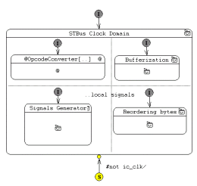
Figure 4: STBus clock domain SyncChart

Horizontal and vertical separator identify concurrent execution of components and denote a composition relation, i.e a STBus aggregates four components : an opcode converter, a reordering bytes component, some bufferization components and some signal generators (themselves refined in other views – see Figure 6 for RQB behavior).

Note the use of suspension (S connector) to freeze the corresponding automaton whenever the relevant clock is absent. Therefore, these behavioral bricks only react on the rising edge of their respective clock.

In order to illustrate the modeling style of SyncCharts, we consider a FIFO queue element; a classic component in system design. The considered bridge integrates five FIFOs in order to manage the asynchronism between peripheral connected to STBus and AVBus.

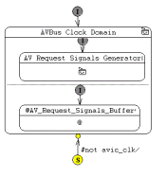
Figure 5: AVBus clock domain SyncChart

As this element constitutes a recurrent component, we propose a design pattern for its behavior to ease its reuse. We choose a modular and generic structure organized in cells. First of all, the behavior of a cell does not depend on the data type on which it operates.

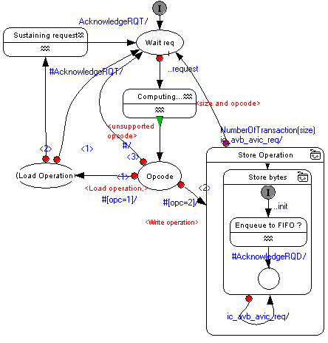Figure 6: RQB Buffer

Then, we introduce an abstract type for the data to memorize. We wish to model a FIFO called “zero-thru” time FIFO which has to push the data at the deepest level, in a single step.

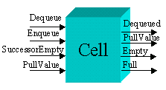
Figure 7: A FIFO cell

Figure 7 gives an external view of a cell via these interfaces. Obviously, in a cell you can en-queue or de-queue data. A cell consumes information (SuccessorEmpty), issued from the next cell in the FIFO, to decide to immediately push or not the data inside its successor. A cell can also transmit its internal state : is this cell full or empty ? Finally, when a data is de-queued, the emptied cell has to pull the data of the previous cell. Figure 8 shows the SyncCharts model of a FIFO cell. Two components run concurrently: one to handle the memorizing phase (at the top) and one to delay concurrent “en-queuing” requests. This last one delays en-queue requests when the cell core (component at the top) is busy. As the core, its role consists in memorizing or transmitting the data to the successor cell. It must keep memorized data when immediate or delayed “en-queue” occurs and immediately de-queue the data (# on transition guards) if the successor cell is empty, if a successor “pulls” its data or if the process wishes to de-queue data explicitly.

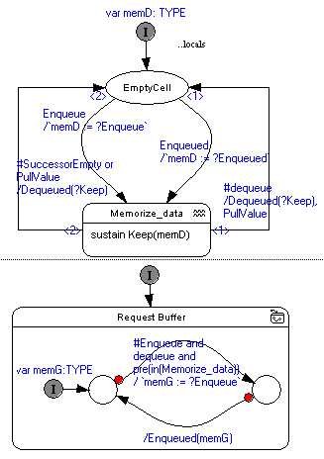
Figure 8: One FIFO Cell

To model a FIFO with n cells, you have to instantiate n times the cell body and judiciously connect the different pins (interface signals). We provide an interconnection schema on Figure 9 for a 2-cell FIFO. Not connecting a signal implies its absence. So, the Esterel compiler only generates code used by application. For instance, for a n-cell FIFO, only the last cell has dequeue signal connected. For the n-1 other cells, the concurrent automaton named “Request Buffer” is inactive (since dequeue is always absent). The compiler uses this knowledge in order to not consider this component.

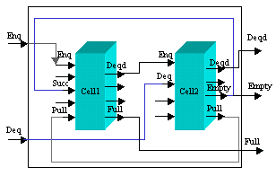
Figure 9: Signal connection for a 2-cells FIFO

Validation environment

Validation of the Esterel models

- Interactive simulation

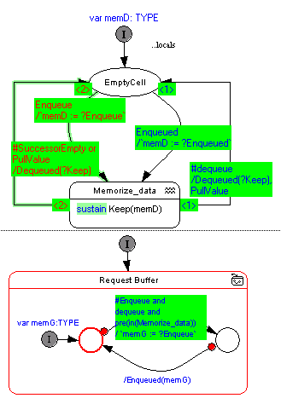
Figure 10: Interactive Simulation

Figure 10 shows a view of the graphical simulator during a data “en-queuing” in a FIFO (the next cell being empty, the data is pushed to this cell). Note that all the consequences of an input event are shown in a single step, so that one can grasp system evolutions at a glance.

- Validation of the STBus properties

The aim is to add passive observer program in parallel with program to check safety, deadlock and vivacity design properties. In Esterel Studio, observers are implemented as Finite State Machines which can have access to all interface signals (inputs/outputs). An observer scans unwanted situations. Verification environment (model checking techniques) formally checks if these situations are never, always or possibly reached. In case of BUG possibly emitted, a scenario leading to the state is produced and can be replayed.

For example, on the AVB1, properties about STBus protocol can be observed:
- Transaction can only occur when request and grant are asserted at a rising clock edge,
- End Of Packet is always emitted on the last transaction, …

- CoWare Co-simulation

Once the Esterel model is validated in the Esterel environment, it is interesting to keep graphic simulations to verify the model in a CoWare system environment. Then, we speak about co-simulation. The first link studied between CoWare and Esterel is based on Unix sockets.

Figure 11: CoWare/Esterel co-simulation

We can see in Figure 11, synchronization between CoWare and Esterel through sockets with TCP protocol. In connected mode, the process whìch wants to read the socket is suspended until the other process writes the socket. On the clock rising edge, CoWare writes the socket with CoWare inputs, the Esterel process is released. CoWare schedules other blocks while Esterel is processing AVB1 model. On the clock falling edge, CoWare reads the socket until Esterel writes output values. Then, output values are put on CoWare buses.

With this solution, co-simulation speed is about 5 K cycles/sec for a small system. To speed up the simulation, we need to have only one process because Unix sockets are very slow. The next step will be to encapsulate Esterel simulation as a slave function in the CoWare block.

State coverage improvement

Confronted to the present system complexity, validation becomes a large stage consuming resources (people, time, …). To functionally validate large systems by hand is out of reach. Our objective, at this step, is to improve the degree of confidence of a design. For sequential systems (control) where “state” is explicitly handled, it seems to be more adapted to consider state coverage rather than code coverage criteria. The methodology proposed in [7], consists in using a model checking tool (formal verifier) to increase the state coverage of a system. From the netlist coming from Esterel compilation, we can generate the set of all reachable states using the model checker. We can extract the reached state by submitting the existing test suite to the system. From these informations, we can compute a state coverage: the ratio of the number of reached states over the number of reachable ones. During simulation, we can find test case redundancies and generate a reduced test suite. Finally, by difference, we can generate test cases to reach states previously non-reached by the initial test suite (see Figure 12).
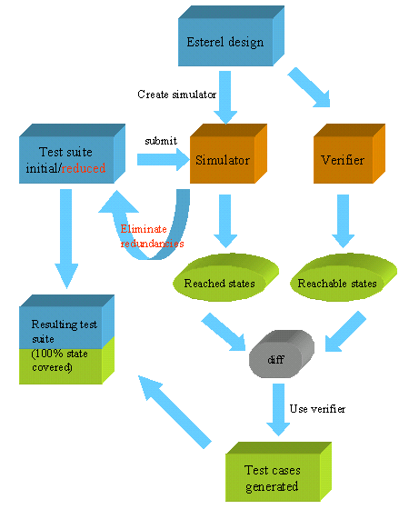
Figure 12: Methodology for state coverage improvement

Perspectives and Conclusions

We have used the Esterel chain to design control dominated part of a hardware module like the STbus to AVBus bridge. From this experiment, some benefits of the Esterel Studio approach have been shown:
- Finite State Machines with Parallelism are more naturally described using a graphical formalism,
- Graphical hierarchy gives models that are simpler, more readable and maintainable,
- With graphical simulations, debug is easier than a simple execution,
- Formal language such as Esterel detects potential inconsistencies during compilation,
- Model checking techniques using BDDs (Binary Decision Diagrams) improve state coverage and test generation,
- Automatic production of target codes allows to have a top down continuous flow.

From this experiment, some limitations have been observed:
- Data dominated part is modeled in C outside the Esterel Studio tool,
- Verification environment cannot be applied when the control part and treatment part are strongly interleaved,
- State coverage step is not yet automated: some state variables (pure signals) have to be added to be observed,
- By design conventions, all output signals must be registered. So, the tool could ease the flip-flop description.

To overcome these problems, several features will be available in subsequent versions of Esterel Studio:
- Embedded data flow definitions in Esterel and corresponding representation in SyncCharts,
- Automatic production of VHDL, SystemC (BCA and RTC) code and co-simulation,
- Automatic test generation

Currently, Esterel Technologies investigates some techniques (static analysis, range analysis, …) to extend verification capabilities, notably in order to take data handling into account.

References

[1] http://www.esterel-technologies.com
[2] G. Berry, The Esterel V5 Language Primer, Ecole des Mines de Paris and INRIA, April 99
[3] Karen Bartleson, « A New Standard for System-Level Design », September 1999. http://www.systemC.org
[4] C. André, “Representation and Analysis of Reactive Behaviors: A Synchronous Approach”, CESA’96, IEEE-SMC, Lille, France, July
[5] Richard Hersemeule, “Fast Prototyping: a system design flow applied to a complex System-On-Chip multiprocessor design”, STMicroelectornics, DAC99
[6] Guido Arnout, “C for System Level Design”, CoWare, Inc. http://www.coware.com
[7] L. Arditi et al., Texas Instruments, Villeneuve Loubet, France, A. Bouali et al., CMA/INRIA Sophia-Antipolis, France, “Using Esterel and Formal Methods to Increase the Confidence in the Functional Validation of a Commercial DSP”, ERCIM workshop on Formal Methods for Industrial Critical Systems, Trento, Italy, 1999
[8] Gilles Pelissier et al., STMicroelectronics, “How to accelerate C to VHDL design flows”, DATE 2001

In numerous cases, it constitutes a reasonable hypothesis (e.g. centralized components). For instance, Combinatory logic naturally accepts this assertion.

